INSERT ADJACENT HTML

### insertAdjacentHtml

### insertAdjacentText

### insertAfjacentElement

//it is actually really simple and don’t need particular heading explanation, the name says it all just see some examples

### Iniitail Html

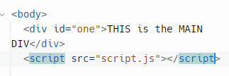

## Beforeend;

//syntax is same just change the locationAddress

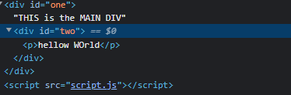

//it willl be places inside that div and before the ending of that div

## Beforebegin

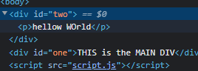

//before the beginning of that div

## AfterEnd

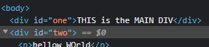

//it will be placed outside that div after the ending of that previously ended div

## Afterbegin

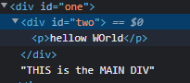

//it will be placed inside the div and in the beginning

# .remove

//use .remove with the object to remove it completely

